
Welcome to The Pure Body Company VIP Subscription Group. Here you can see all the Terms & Conditions for the VIP Group and a list of all the Benefits and joining conditions.

There are many benefits to being part of the VIP Group for TPBC, just 2 simple conditions to participate.
- You are required to maintain your DD or membership for a minimum of 6 months to qualify for the benefits straight away. You may pay the annual fee of £60 or DD £5 per month. The monthly DD has a requirement to pay the first 4 months in front @£20, the remainder to be in DD @£5 per month for an additional 8 months.
- The Client must take treatments minimum of every 4 weeks. There is no upper limit on the additional treatments taken though each pass only covers the named VIP client for Treatments only

Events and online courses may be purchased as gifts in multiple and sent as a gift voucher.
Termination of pass
The pass will remain open if the monthly or annual payment is made, the four weekly treatments are being taken and the VIP client hasn’t requested a break due to illness. Once the client treatments lapse to outside the 4 weeks, the client will loose the discount for future appointments, unless,
Prior notice has been received and confirmation of the suspension or termination of the VIP pass has been granted. If no notice is received, the pass will be monitored for a further 2 weeks before being cancelled. This is to avoid those annoying subscriptions that continue to pay. You can always reinstate your pass by starting again. Due to the value of the discounts and the subscription cost, no refunds will be given for any unu
In the even that a client has paid annually for the subscription, after the 6-month period if the 4 weekly treatment is not being used £20 will be refunded to the client and the pass will be cancelled.
All Terms & Conditions regarding appointment booking are still current and can be found on the VIP page and as a condition or proceeding with the sale on the booking form.
The VIP pass may not be used in conjunction with any other offer from The Pure Body company Unless authorised by Janet Lee and that same offer is made available to all VIP members.

Benefits
Benefits are available on treatments
Discounts available of Sugaring packages., not single individual treatments. Booking Sugaring appointments every 4 weeks will qualify VIP clients to the monthly return policy in place to ensure the pass is active.
On average over a year with a VIP full leg, Hollywood and Under arm package the VIP client will save up to £200 if more treatments are booked for example the Fascial facial and massage treatments, savings can be up to £700 over the course of a year.
See the table below for a full breakdown of possible savings.
 | Treatment
 | Ful Leg, Hollywood & Under Arm | Full Leg, Brazilian & Under Arm | Blend Fascial Facials, 90 min | Aromatherapy, Reflexology Deep Tissue, 90 min | Blend TMJ  90 min | Blend Scar Therapy  90 min | Gents, full leg, back, chest. shoulders
Regular price | £130 | £125 | £130 | £120 | £120 | £130 | £170
VIP Subscription | £110 | £105 | £110 | £100 | £100 | £110 | £150
Saving | £20 | £20 | £20 | £20 | £20 | £20 | £20
Annual Saving | £260 | £260 | £260 | £260 | £260 | £260 | £260
Subscription | £60 | £60 | £60 | £60 | £60 | £60 | £60
Total Saving per year | £200 | £200 | £200 | £200 | £200 | £200 | £200

With one treatment being taken 4 weekly, our VIP clients can have additional treatments and receive the discount each time they book, increasing the saving per year.
A VIP client may choose The Full leg, Hollywood and underarm package and save £200 per year and have Blend fascial facial once every 3 months and receive and additional £20 in savings for each facial, totalling £260 in savings per year. The qualifying 4 weekly treatment being the 4 Weekly Sugaring treatment.

Events & Courses
We host quarterly events, socials for small groups in the Blackfriars area, venue dependant on the group size. Where we have an open forum for clients are able to sample upcoming products we have on sale, test new therapies and find out about existing therapies and how they can benefit. The events are very informative but fun plus we have local catering from some amazing local restaurants. VIP client will get a £20 discount on one ticket and £5 discount on additional tickets. You will be informed in emails and in the private VIP group about upcoming events.

Some of the products we have available
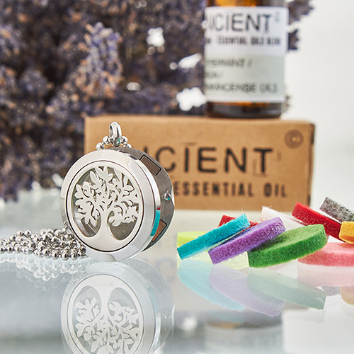

Sample Taster menu
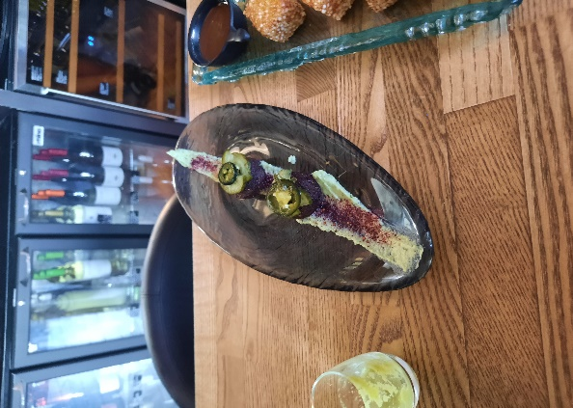
Courses
Our Courses Are available all year round and offer our VIP clients a £25 discount for the first course and £5 for additional courses purchased. Full Terms and Conditions are available, and you will need to tick to confirm before purchasing the courses, event tickets and treatments.
Just a few of the upcoming and available courses we offer.

Usual Price £125;00, VIP price £100, Inc support for 6months via private FB/Wix groups to assist in the removal of harmful chemicals from your cleaning routing without spending a fortune or damaging your surfaces.
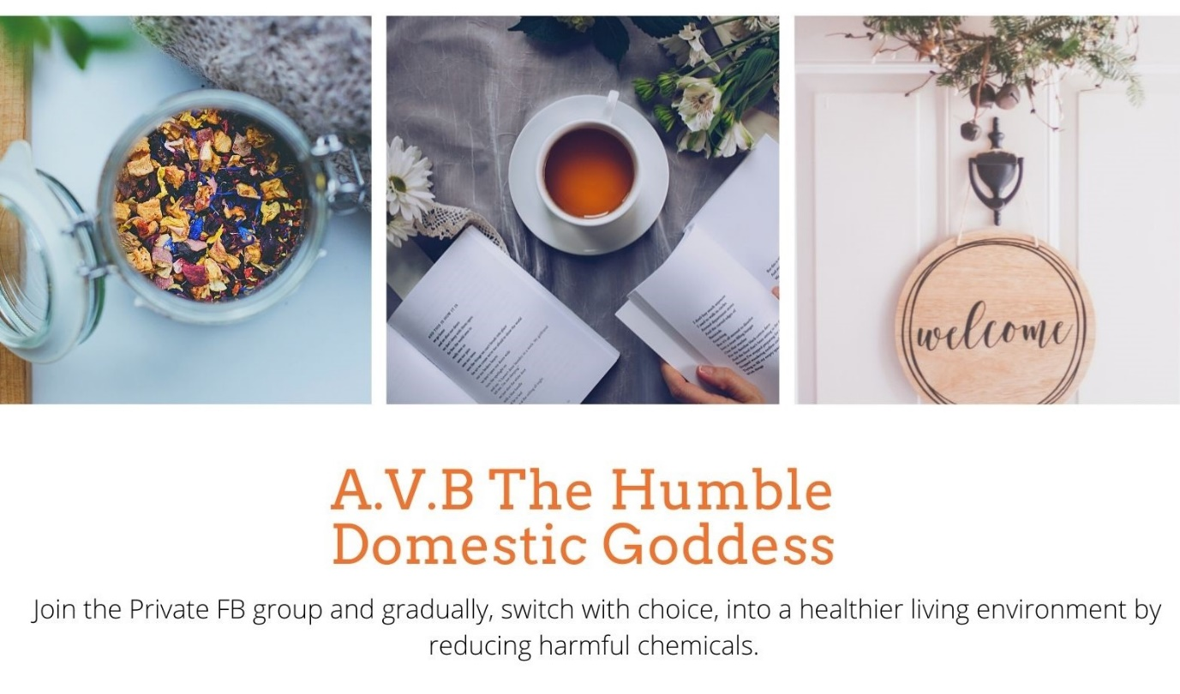
The Art of Home sugaring, Non professional course with 6 months access to videos and support via a private FB/Wix groups.
Usual price £150, VIP clients £125.00
Access for 6 months to this online course teaching you all you need to know to sugar yourself at home. To help you out If the unthinkable happens again and we can’t meet up. Plus, guidance for 6 months from TPBC Sugaring Specialists to guide your though any questions you have.
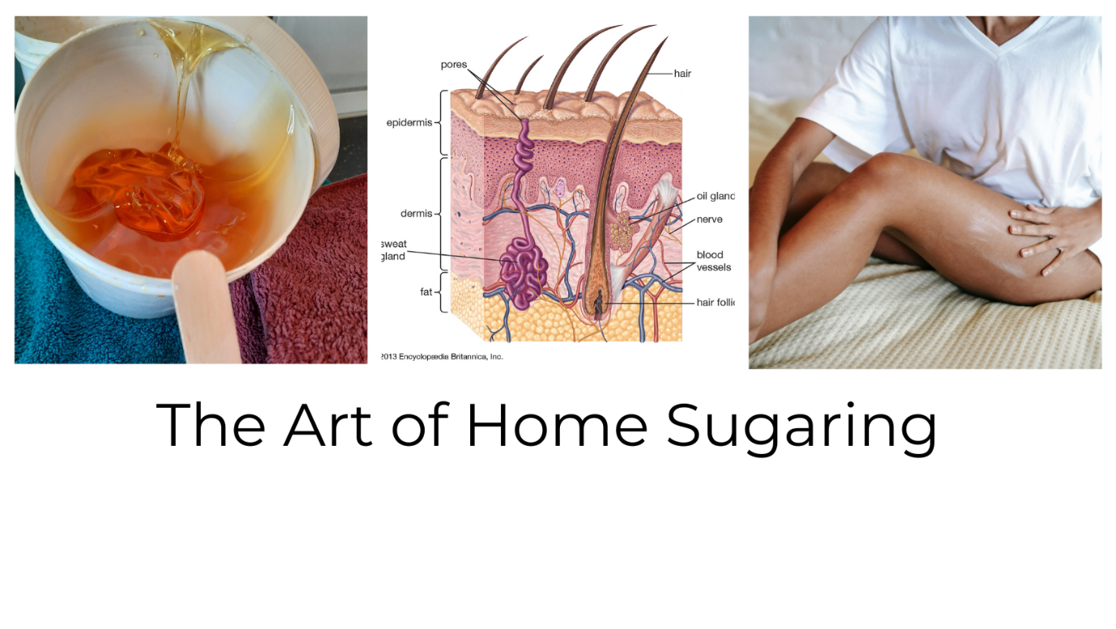
Any questions about the VIP group in the first instance Email or text
thepurebodycompany@gmail.com
mob 07983285073
Hope to see you soon
Janet @ The Pure Body Company.

